Binary and Logic Gates Quiz Name:

Version 1

Part 1

Convert the following Decimal numbers to binary

| Decimal | 24  16s | 23  8s | 22  4s | 21  2s | 20  1s |
| --- | --- | --- | --- | --- | --- |
| 27 |  |  |  |  |  |
| 19 |  |  |  |  |  |
| 7 |  |  |  |  |  |
| 30 |  |  |  |  |  |
| 12 |  |  |  |  |  |

Part 2

Convert the following Binary numbers to decimal

| Decimal | 24  16s | 23  8s | 22  4s | 21  2s | 20  1s |
| --- | --- | --- | --- | --- | --- |
|  | 1 | 1 | 1 | 0 | 0 |
|  | 0 | 1 | 1 | 0 | 1 |
|  | 0 | 1 | 1 | 1 | 1 |
|  | 1 | 0 | 1 | 0 | 1 |
|  | 1 | 0 | 1 | 1 | 0 |

Part 3

Binary numbers are the ‘lowest level’ of abstraction in a computer. ASCII and Unicode are higher levels of abstraction. Explain how data can be represented by ASCII/Unicode and then, in turn represented in bits.

Part 3

Fill out the truth table for an AND gate

| A | B | Z |
| --- | --- | --- |
| 0 | 0 |  |
| 0 | 1 |  |
| 1 | 0 |  |
| 1 | 1 |  |

Fill out the truth table for an OR gate

| A | B | Z |
| --- | --- | --- |
| 0 | 0 |  |
| 0 | 1 |  |
| 1 | 0 |  |
| 1 | 1 |  |

Fill out the truth table for a NOT gate

| A | Z |
| --- | --- |
| 0 |  |
| 1 |  |

Fill out the truth table for the following digital circuits

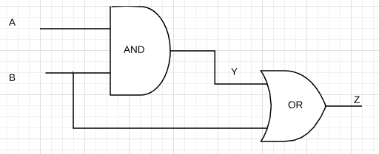

| A | B | Y | Z |
| --- | --- | --- | --- |
| 0 | 0 |  |  |
| 0 | 1 |  |  |
| 1 | 0 |  |  |
| 1 | 1 |  |  |

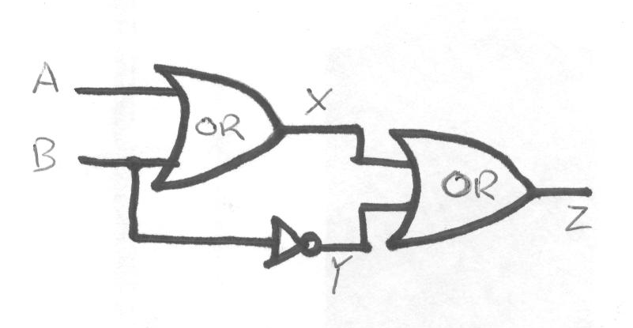

| A | B | X | Y | Z |
| --- | --- | --- | --- | --- |
| 0 | 0 |  |  |  |
| 0 | 1 |  |  |  |
| 1 | 0 |  |  |  |
| 1 | 1 |  |  |  |

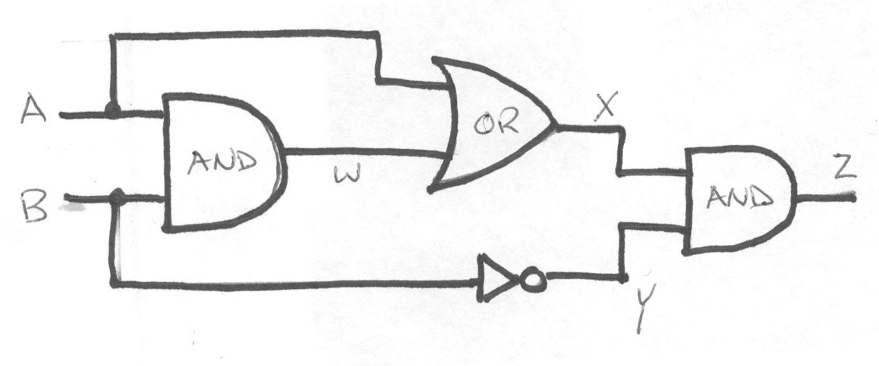

| A | B | W | X | Y | Z |
| --- | --- | --- | --- | --- | --- |
| 0 | 0 |  |  |  |  |
| 0 | 1 |  |  |  |  |
| 1 | 0 |  |  |  |  |
| 1 | 1 |  |  |  |  |

Binary and Logic Gates Quiz Name:

Version 2

Part 1

Convert the following Decimal numbers to binary

| Decimal | 24  16s | 23  8s | 22  4s | 21  2s | 20  1s |
| --- | --- | --- | --- | --- | --- |
| 22 |  |  |  |  |  |
| 17 |  |  |  |  |  |
| 20 |  |  |  |  |  |
| 29 |  |  |  |  |  |
| 11 |  |  |  |  |  |

Part 2

Convert the following Binary numbers to decimal

| Decimal | 24  16s | 23  8s | 22  4s | 21  2s | 20  1s |
| --- | --- | --- | --- | --- | --- |
|  | 1 | 1 | 0 | 1 | 1 |
|  | 0 | 1 | 0 | 0 | 1 |
|  | 0 | 1 | 1 | 1 | 1 |
|  | 1 | 0 | 0 | 1 | 1 |
|  | 1 | 0 | 1 | 0 | 1 |

Part 3

Fill out the truth table for a NOT gate

| A | Z |
| --- | --- |
| 0 |  |
| 1 |  |

Fill out the truth table for an OR gate

| A | B | Z |
| --- | --- | --- |
| 0 | 0 |  |
| 0 | 1 |  |
| 1 | 0 |  |
| 1 | 1 |  |

Fill out the truth table for an AND gate

| A | B | Z |
| --- | --- | --- |
| 0 | 0 |  |
| 0 | 1 |  |
| 1 | 0 |  |
| 1 | 1 |  |

Fill out the truth table for the following digital circuits

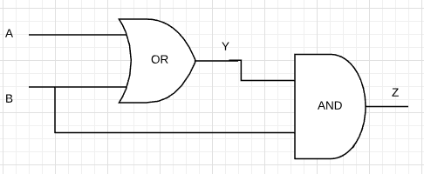

| A | B | Y | Z |
| --- | --- | --- | --- |
| 0 | 0 |  |  |
| 0 | 1 |  |  |
| 1 | 0 |  |  |
| 1 | 1 |  |  |



| A | B | X | Y | Z |
| --- | --- | --- | --- | --- |
| 0 | 0 |  |  |  |
| 0 | 1 |  |  |  |
| 1 | 0 |  |  |  |
| 1 | 1 |  |  |  |

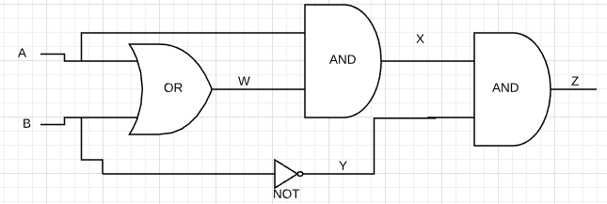

| A | B | W | X | Y | Z |
| --- | --- | --- | --- | --- | --- |
| 0 | 0 |  |  |  |  |
| 0 | 1 |  |  |  |  |
| 1 | 0 |  |  |  |  |
| 1 | 1 |  |  |  |  |